RAINOW PRIMARY SCHOOL
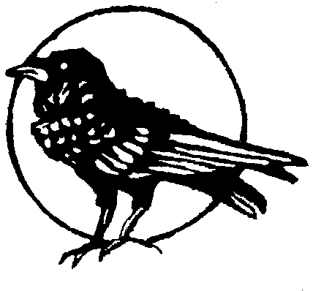

Headteacher: Round Meadow
Mr J D NORRIS Rainow
Macclesfield
Telephone: Cheshire
01625 572021 SK10 5UB

Caring, Learning, Achieving.

E-Mail Address admin@rainowpri.cheshire.sch.uk
Website www.rainowpri.cheshire.sch.uk

29 July 2026
Outbreak…Book a PCR
Dear Parent / Carer
We have been informed that a number of individuals in our setting have tested positive for COVID-19. This is now classed as an outbreak.
We know that you may find this concerning, but we are continuing to monitor the situation and are working closely with Public Health and the local authority to identify recent contacts and put in place additional infection control measures. As your child is in the group where the outbreak has occurred, Cheshire East Public Health have recommended that they take a PCR test. Anyone who has tested positive for COVID-19 test in the last 90 days should not take another PCR test unless they have symptoms but is advised to take a lateral flow test instead. This testing is to check if they have contracted the virus, so that you and they are able to make decisions to limit the spread of COVID-19.
Close contacts are not required to isolate.
Your child can and should continue to attend the setting as normal. They can also carry out all other activities in line with national guidance and following all safety measures which have been put in place based on national and local Public Health advice.
All adults and many young people are now eligible for COVID vaccines. To check eligibility and how to get a vaccine visit NHS coronavirus vaccine information or Cheshire East coronavirus vaccination programme.
What to do if anyone in the household develop symptoms of COVID 19
If anyone develops symptoms of COVID-19, they should remain at home and book a PCR as advised in https://www.gov.uk/government/publications/covid-19-stay-at-home-guidance.
Anyone with symptoms can request a test for via https://www.gov.uk/guidance/coronavirus-covid-19-getting-tested.
Further Information
Further information is available at https://www.nhs.uk/conditions/coronavirus-covid-19/
Yours sincerely
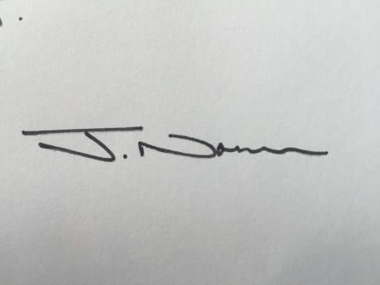
Mr Norris
Headteacher

