Instructions for Booking your Appointment for Parents’ Evening

You will already have received your user-id and password via pupil post. Enter www.rainowpri.cheshire.sch.uk and click on the PARENT LOGIN option shown below.

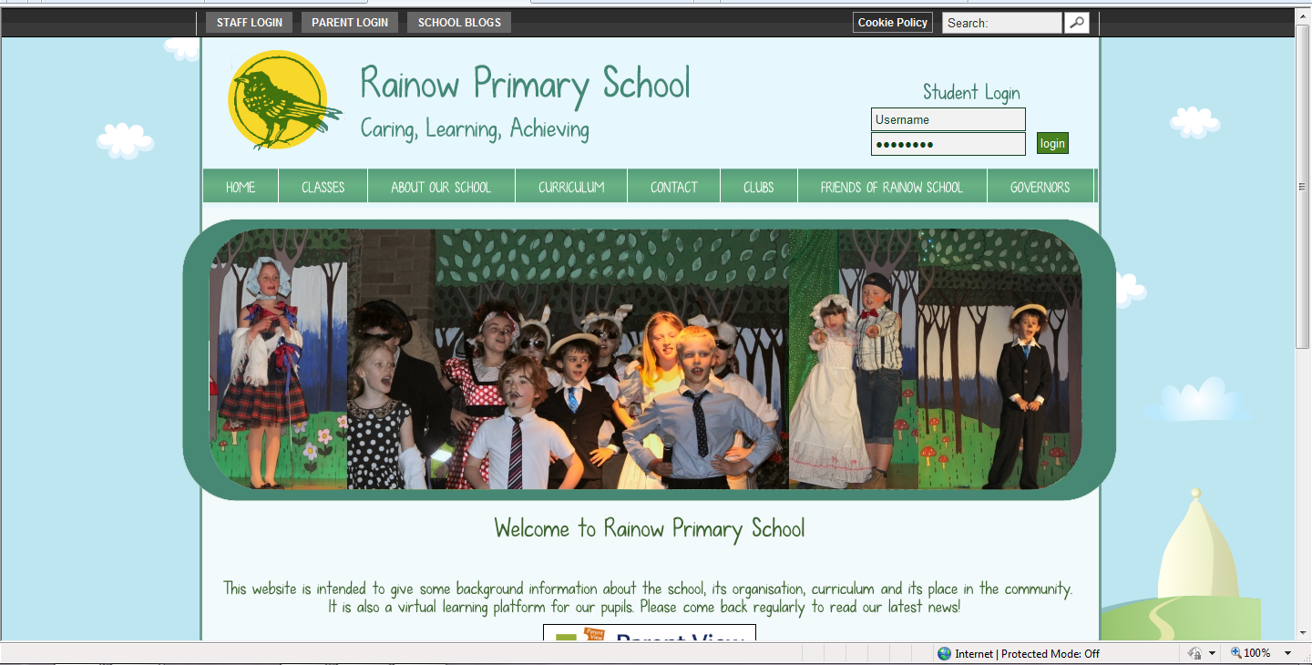
You will then be presented with the screen below which will list all the pupils you are associated with. Click on the Parents’ Evenings option
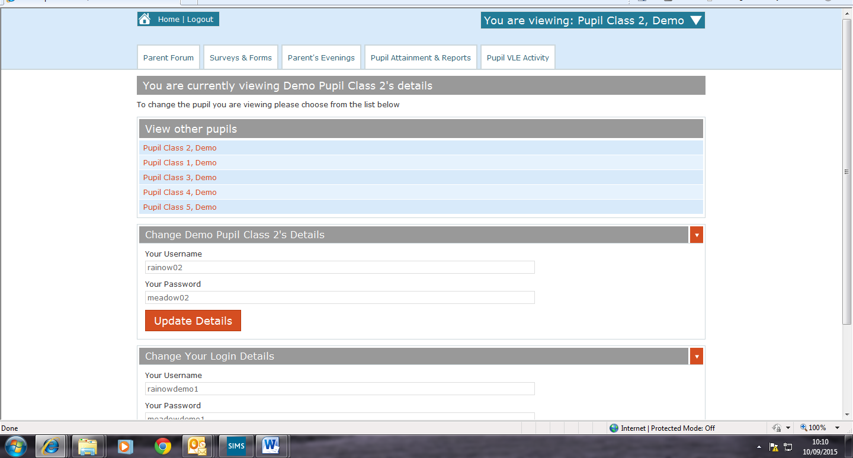
You will then see the screen below. The blue drop down box will show which child you are making an appointment for.
Please note that the view you see relates to this child only.
Click on the day you wish to make an appointment.
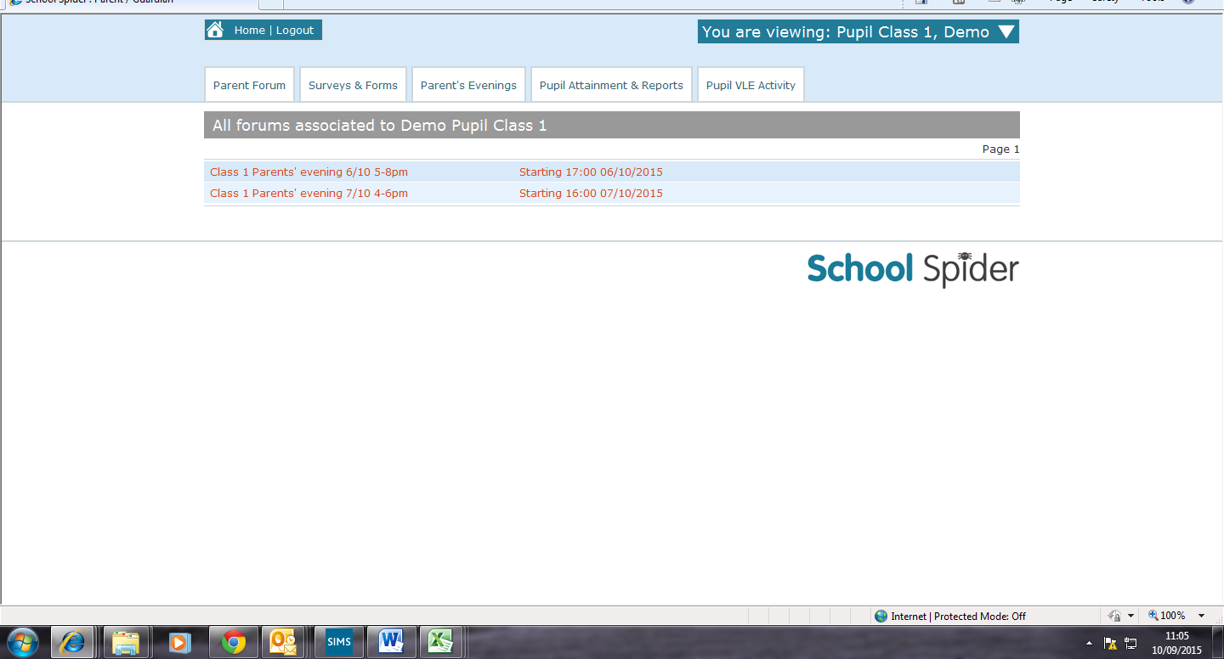

You will then see the screen below. All available slots are show in red and you can select your preferred time by clicking on the relevant red slot.
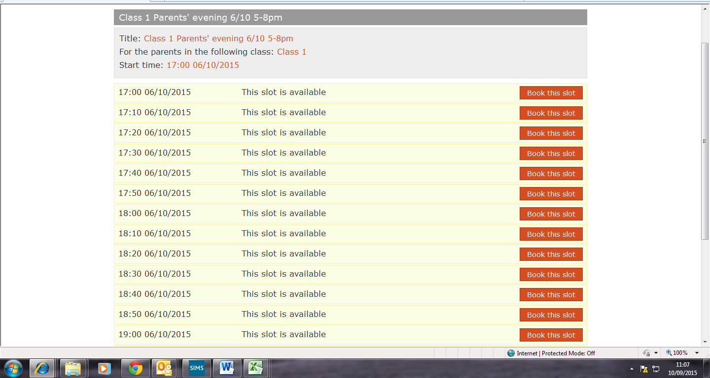
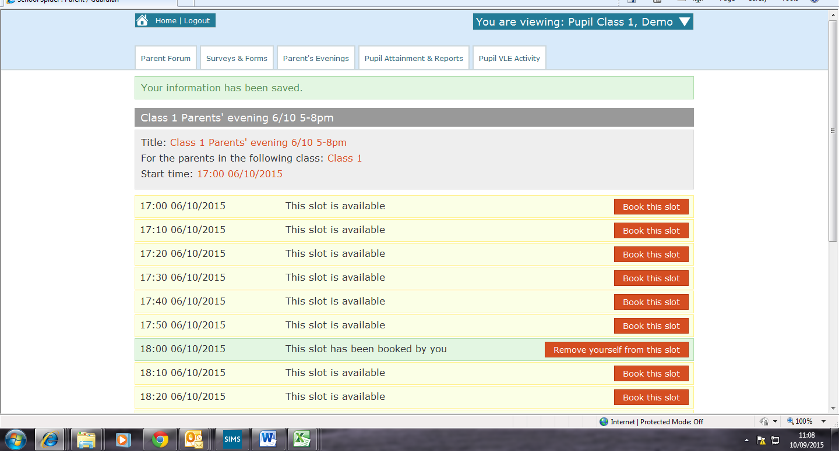
Once you have booked your slot you will see the screen below. If you have more than one child in school please click on the white arrow in the blue drop down box to select a sibling and repeat the process from the top of page 2.

As shown in the screen above, the slot has been booked and once you have finished booking your appointment times you can log out of the system.

If at any point you wish to check your appointment time, simply log back into the system and you will be able to see the slot you have booked as shown above.

